**All components of this case study have to be executed in R.**

DATA PREPARATION:

1. Make a grouped bar chart depicting the hour-wise trip request made at city and airport respectively. You can aggregate the data for all 5 days on the same axis of 24 hours. Each bar should correspond to an hour and pick-up point (city / airport) should be displayed in two colors.

*Please paste a copy of your plot here.*

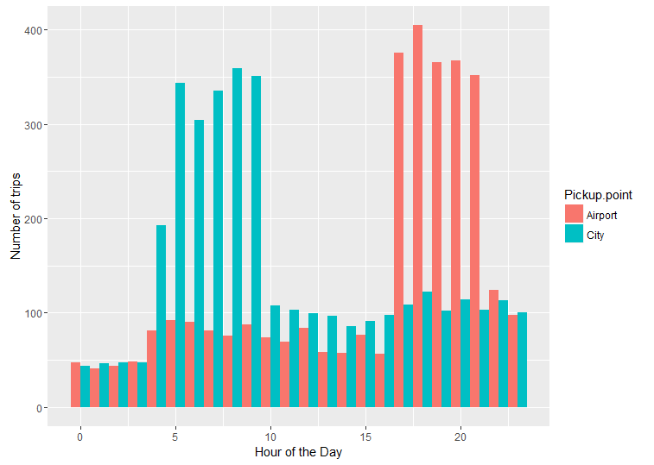

1. In the bar chart (question 1), you’ll be able to see 5 major time blocks based on the frequency of requests made at the city and airport. You have to now divide the request-time into 5 time-slots described below. Make an additional column “Time_Slot” which takes these 5 categorical values depending on the request time:
   * Pre_Morning  (00:00 to 05:59)
   * Morning_Rush  (06:00 to 10:59)
   * Day_Time  (11:00 to 16:59)
   * Evening_Rush  (17:00 to 20:59)
   * Late_Night  (21:00 to 23:59)

Note: The division of time-slots may not have one right answer.

*Plot a bar chart for number of trips made during different time-slots in R and paste the image here*

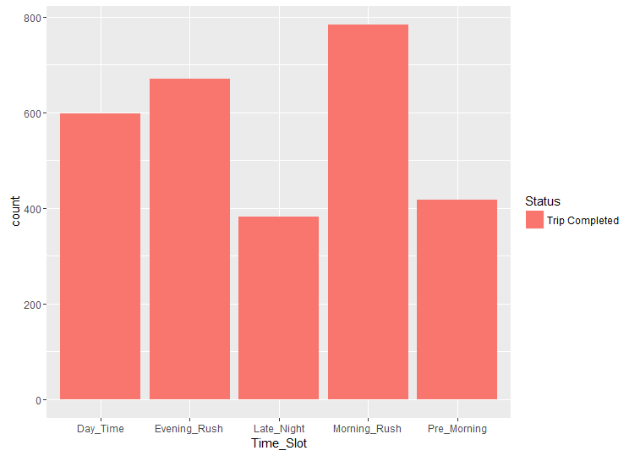

Also give the count of the number of trips made during different time slots you have decided.

* Pre_Morning: 417
* Morning_Rush: 784
* Day_Time: 598
* Evening_Rush: 671
* Late_Night: 382

PROBLEM IDENTIFICATION:

1. Make a stacked bar chart where each bar represents a time slot and y axis shows the frequency of requests. Different proportions of bars should represent the completed, cancelled and no cars available out of the total customer requests.

*Please paste a copy of your plot here.*

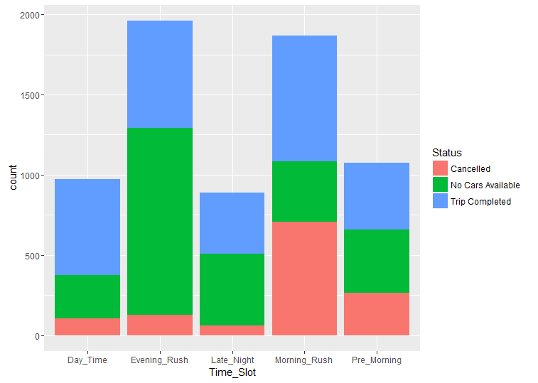

1. Visually identify the 2 most pressing problems for Uber, out of the 15 possible scenarios (5 slots * 3 trip status).
2. Enter your diagnosis results here:

* Problem 1:  Large number of cancellations in the morning rush hours (between 6am to 10 am)
* Problem 2:  Not enough cars available during evening rush hours (between 17:00 to 20:00 hours)

 Problem 1:

1. For the time slot when problem 1 exists, plot a stacked bar chart to find out if the problem is more severe for pick-up requests made at the airport or the city. As a next step, you have to determine the number of times this issue exists in that time slot.

* Find the percentage breakup for the total number of issues in this time slot based on the pick-up point.

*Please paste your plot here.*

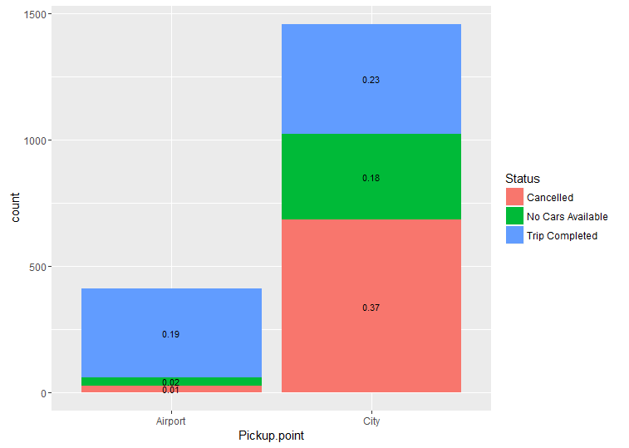

* What is the percentage of total issues at (based on pick-up point):
* Airport : 1% cancellations during morning rush hour
* City : 37% cancellations during morning rush hour

1. Now let’s find out the gap between supply and demand. For this case, the demand is the number of trip requests made at the city, whereas the supply is the number of trips completed from city to the airport.

*No. of trip requests made in city:* ***1457 during morning rush hour***

*No. of trips completed from city to airport:* ***434 during morning rush hour***

1. What do you think is the reason for this issue for the supply demand gap? (Write the answer in less than 100 words).

* It is uneconomical for cabs moving from city to airport to come back empty, especially during the morning rush hours. Cabs at the airport are waiting for customers from the airport itself. Hence bookings from the city are cancelled.
* More trips can be made within the city instead of waiting in the airport. Hence cabs in the city deny airport requests

1. What is your recommendation to Uber (Not more than 50 words)?

**Provide an additional incentive for airport drops during morning rush hour to compensate for the loss of business and an empty journey back to the city.**

Problem 2:

1. For the time slot when problem 2 exists, plot the stacked bar chart to find out if the issue is for pick-up request made at the airport or the city. Just like problem 1:

* Find the percentage breakup for issue based on the pick-up point for the time slot in which problem 2 exists.

Please paste your plot here.

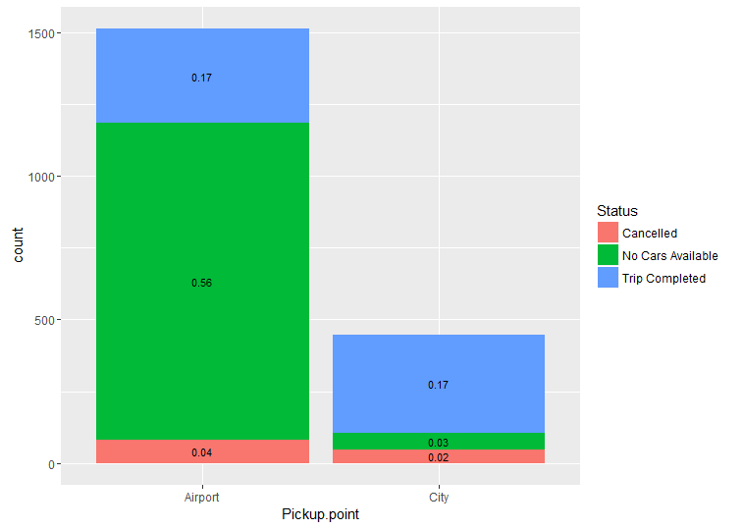

* What is the percentage of total issues at (based on pick-up point):
* Airport : 56% during evening rush hour
* City : 3% during evening rush hour

1. Now let’s find out the gap between supply and demand. For this case, the demand is the number of trip requests made at the airport, whereas the supply is the number of trips completed from airport to the city.

*No. of trip requests made at the airport:* ***1514 trips requested***

*No. of trips completed from airport to the city:* ***329 trips completed***

1. What do you think is the reason for this issue for this supply demand gap. (Not more than 100 words)?

The problem is related to the previous problem. Since there are a lot of cancellations from the city to the airport, there is not enough supply at the airport to meet the demand during evening rush hours.

1. What is your recommendation to Uber (Not more than 50 words)?

**Provide additional incentives for airport trips, or compensate the driver for the waiting the waiting time at the airport. Uber can also mandate minimum number of airport trips to qualify for incentives.**